2016 Prescribed Burn Report
December 29, 2016

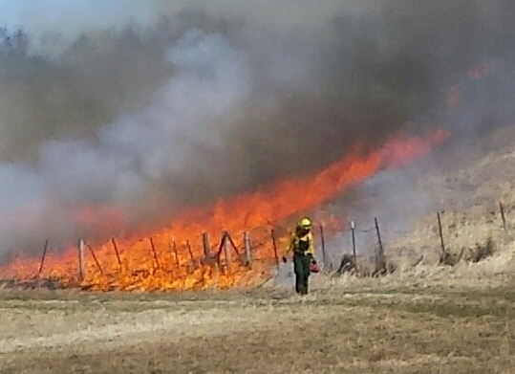

The primary spring burn season ended as of April 20, 2016. Staff is planning on conducting additional growing season burns in the “Pheasants Forever” prairie restoration north of Harts Road. These burns will be closely studied to monitor the impact of fire on invasive shrub invasion and any negative impacts to wildlife. The burns will be small and conducted in a way to allow wildlife to escape the flame front. The total acreage burned on District property in the spring of 2016 was 2144 acres, which is above the five-year spring burn average. LPNR staff conducted 42 prescribed burns on 20 burn days over a 55-day burn season (February 26 to April 20). There were an additional 4 potential burn days on the weekends (Saturday and Sunday) of the spring burn season. One of those days, April 16 was used to conducted wildland fire training with the McHenry County College Fire Academy. On March 10, staff responded to one wildfire at the Kiswaukee Corridor from welding work being conducted on the HUM Railroad Prairie. Overall, there were very few days where relative humidity dropped below 30%. This resulted in a relatively mild burn season for wildfires, spot fire activity, and fire intensity. Since the burn season was so long, the results are already in at number of locations. The prescribed fires that were conducted did their job. Invasive brush was set back, vegetation structure manipulated, and native vegetation stimulated. The sites are looking good.
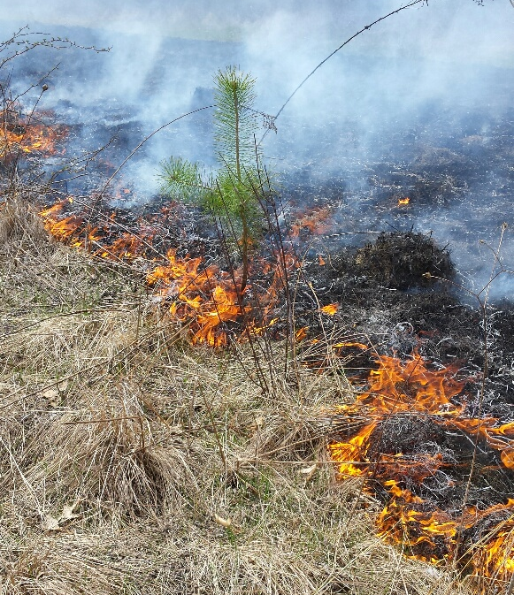
Prairie Restoration burn at Lake Elizabeth, April 5, 2016

This year we burned several areas for the first time; the Keebler wetland at Alden and the Barki easement at Marengo Ridge. The prairie restoration along Rt. 31 and Harts Road in the “Maple Square” project was also burned for the first time. We burned the Becks Woods mitigation site, which should help in achieving vegetation standards at this location. We burned the fifth most acres in the spring with a very limited staff with no escapes or jumps.
Sites and Fleets staff conducted an additional 15 burns on 22 acres. Their burns consisted of “no mow” areas, prairie restorations in developed areas, and a few natural areas adjacent to, or in developed areas. These burns are important in to the District’s prescribed burn program. These areas are very visible to the public so it is beneficial that they receive burn management on a regular basis. In addition, LPNR and S&F crews join forces on larger burn units during the very limited burn season.
Overall, it was an excellent burn season. I want to personally thank everyone for the hard work, careful planning, and expertise that goes into every burn. We got a lot done and everyone’s contributions was greatly appreciated. To start off, we were prepared and ready to go on day one. The equipment was repaired and maintained and operational every day. The burns were safe and efficiently conducted because they were well planned, scouted, and conducted with good firebreaks. We worked with our Sites and Fleets staff and volunteers on the majority of our burns. Without their assistance, our overall acreage would be significantly less.
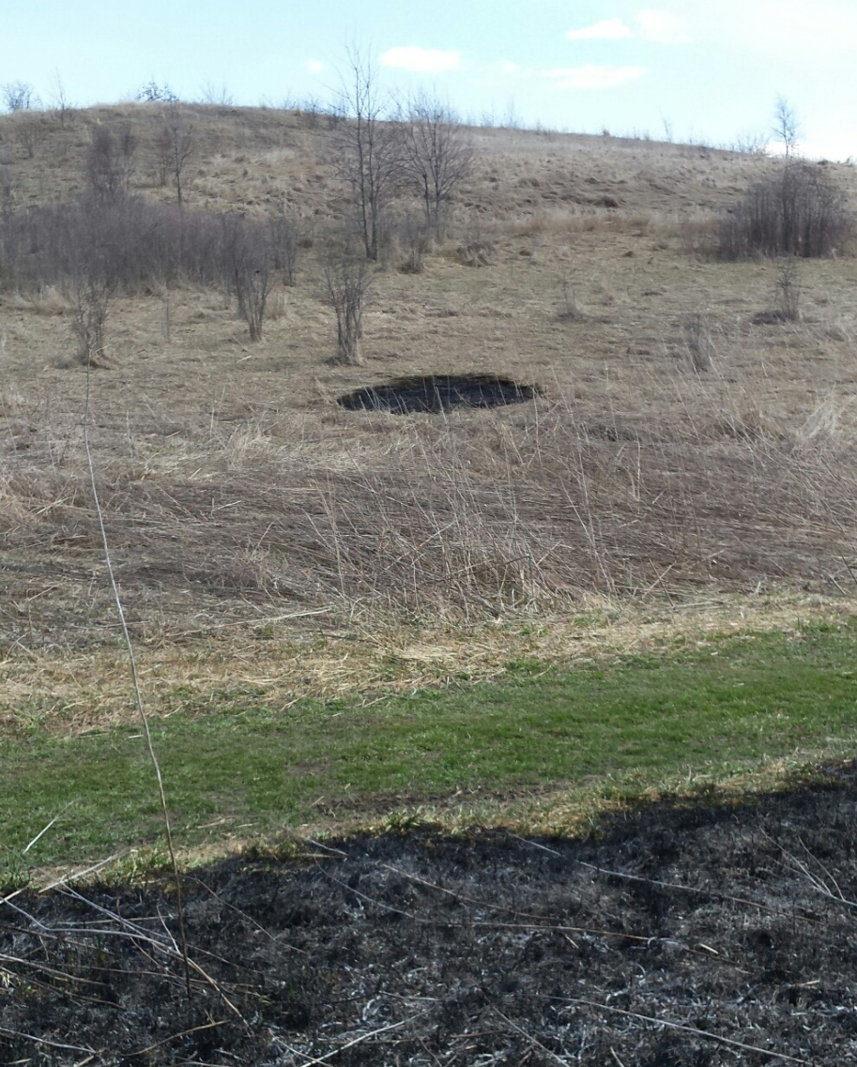
Spot fire during the Kames burn on March 21, 2016. Crews must always be alert and ready to respond.

Some other facts to ponder; the spring burn season was 9 weeks long. We were, however, only able to utilize split crews on 7 of the 20 regular (Mon-Fri) burn days. Our LPNR burn team of 4 RE, 2 RT, 1 PE, 1 WE, 1FSE, 1 Manager and 1 NRPC = 11 full time staff. When we split crews, we must typically recruit 5-7 additional staff and volunteer to have two functional burn crews. Teaming with Sites and Fleets and finding good volunteers is extremely important to the District’s burn program. With a full complement of staff, we could have easily split crews on several more occasions. If we could have split crew on 7 additional days it would have resulted in an additional 350-400 acres burned. At $100/acre (burn cost estimate in the private sector) this would equate to an additional $40,000 of work completed.

Important Considerations
- Always have more burns on your list than you can possibly do. This means preparing firebreaks, sending out burn letters, etc. for up to 50 burn units (we had 62 units on our burn list in 2016). The reason for this is the weather can be unpredictable and eliminate a large number of units because of smoke management concerns. We were still able to burn on every available burn day even after multiple days of SE winds and relatively poor smoke dispersal. With only a limited number of burn units, we would have run out of sites to burn.
- Units with great fire breaks get burn more frequently over time. They are safer to burn, more efficient (less staff required and completed much faster) and just plain easier to do. Good fire breaks also allow us to burn the unit in multiple wind directions. Investing time in fire break preparation should be a year round activity.
- We should discuss an evening and weekend crew. Perhaps one day per week, 6-7 staff members could work late or work on a weekend to get more burning done.
Processes
Daily email – burn boss and locations -necessary and helpful
Scheduling volunteers and Sites and Fleets staff - edit volunteer list, keep calling fire depts.
Have Sites and Fleets burn boss check with Regional Ecologist to double check and coordinate before burning.

Equipment
Equipment and supply needs- more burn signs, foam, flashing lights on ATV’s
Firebreaks- need to be mowed 2x, prepare for fall and next spring
High visibility Nomex vests for working near roadways
Purchase 1 additional slip in pickup pumper (create 3rd burn crew)
Purchase 1 additional ATV with high pressure sprayer (create 3rd burn crew)

Staffing and Labor
Big burns- need to function as one crew

Glacial Park Kames, Spring 2016.
MCCD Burn Acreage.

Spring Burn Season Ave. Acres Total # Ave. Size
Burned Burns Burn in Acres
3 Year Ave. 2487 112 65
5 Year Ave. 2176* 167 62 *2013 was a terrible year for burning

Best 3 Years 2837 129 70 Years were 2009, 2014, 2015

Spring + Fall Season Ave. Acres Total #
Burned Burns

Best 3 Years 3021 132 Years were 2009, 2012, 2014

Number of burn days per week (weeks 1-8). The table starts the first week in March (except in 2016) and ends last week in April. The best weeks are highlighted in green. The only pattern I see is there is typically one really good weather week where conditions for burning are generally good. Each year and each season is quite unique.

 | March |  |  |  | April
 | 1 | 2 | 3 | 4 | 5 | 6 | 7 | 8
2009 | 1 | 0 | 5 | 1 | 0 | 4 | 3 | 3
2010 |  |  | 3 | 4 | 4 | 3 | 3
2011 |  | 5 | 0 | 4 | 2 | 5 | 1
2012 | 1 | 4 | 2 | 4
2013 |  |  | 1 | 5 | 0 | 1 | 4 | 1
2014 |  |  |  |  | 3 | 5 | 3 | 3
2015 |  |  | 5 | 0 | 4 | 1 | 3
2015 | including Saturdays |  | 5 | 0 | 5 | 2 | 4

2016 (Feb)1 1 2 2 2 2 2 6 2

Spring Burn Season averages 16 “Burn Days” per year. See below.

 | Date | Burns | Length | Days | Acres | Dates
 | 2007 | 22 | 30 | 15 | 1643 | 19-Mar | 18-Apr
 | 2008 | 27 | 29 | 15 | 1961 | 26-Mar | 24-Apr
 | 2009 | 49 | 49 | 17 | 3054 | 6-Mar | 24-Apr
 | 2010 | 32 | 27 | 19 | 1839 | 18-Mar | 14-Apr
 | 2011 | 36 | 38 | 17 | 2180 | 14-Mar | 21-Apr
 | 2012 | 29 | 21 | 11 | 1780 | 9-Mar | 29-Mar
 | 2013 | 26 | 32 | 12 | 1450 | 28-Mar | 20-Apr
 | 2014 | 35 | 24 | 14 | 2752 | 31-Mar | 23-Apr
 | 2015 | 35 | 34 | 16 | 2355 | 16-Mar | 18-Apr
 | 2016 | 42 | 55 | 20 | 2144 | 26-Feb | 20-Apr

In 2009, we burned one day each in January and February (acres included in total).

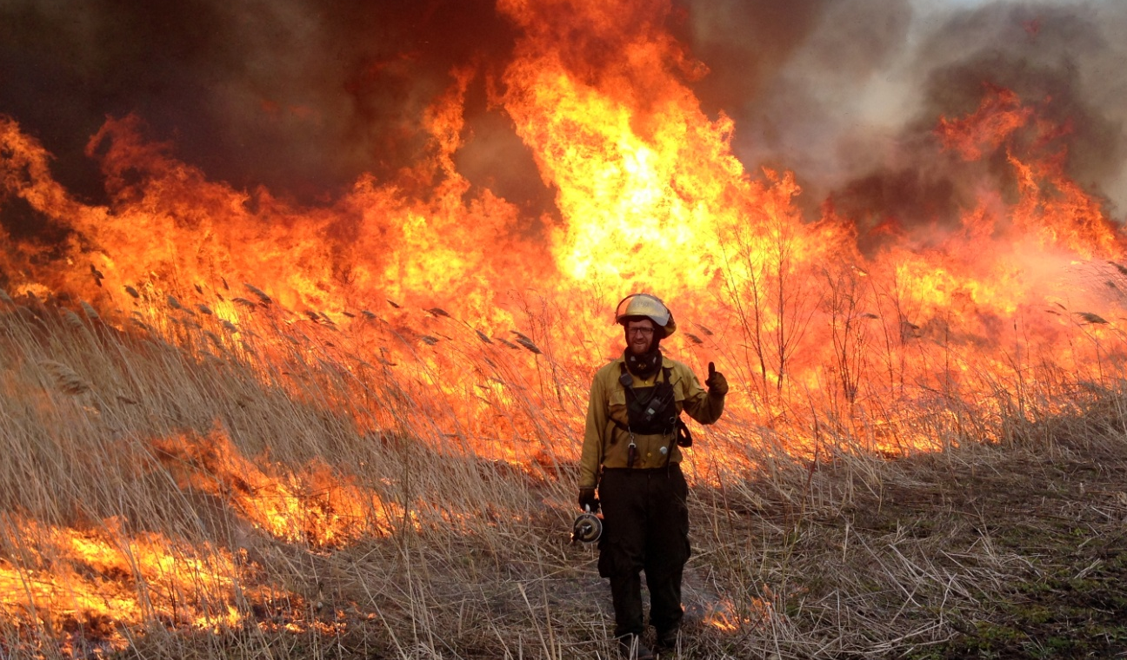
Adam Rex at Pleasant Valley, Spring of 2016.

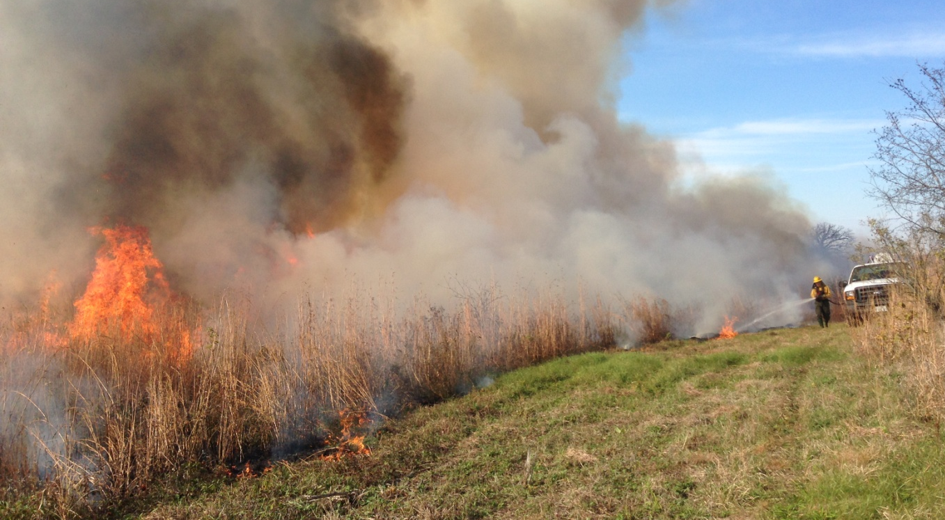
Tom Simpson at Pleasant Valley, Fall of 2015.

Spring vs. Fall. Average number of fall burn days is 8 if you exclude 2009.

Staff was able to add 7 weeks to the burn season in 2016 (four weeks in September and three in October). Previously, we did not burn in this time period. We did not burn in August this year, but in the future, given the right weather and burn unit, we can. Staff conducted 8 burns in September and 2 in the first three weeks of October. Previously, this time period was not utilized for burning. According to historic burn literature, the fall was the time period when the prairie burned. If you look closely at the weather data below, consider plant phenology, live fuel moisture and especially seasonal drought; fall is a prime time for conducting prescribed burns.
Burn Weather Data for Northern Illinois.
 |  |  |  |  |  |  | Previous | 2016
 | Temp | Temp | Ave Rain | Snow | Ave RH | Ave RH | Burn | Planning
SPRING | Ave High | Ave Low | Inches | Days | High | Low | Weeks | Weeks
March | 45 | 26 | 2.2 | 13 | 82 | 59 | 2 | 2
April | 58 | 37 | 3.5 | 5 | 80 | 51 | 4 | 4
May | 69 | 47 | 4 | 1 | 80 | 50 |  | 2
FALL
August | 81 | 60 | 4.1 | 0 | 90 | 55 |  | 2
September | 74 | 52 | 3.4 | 0 | 90 | 54 |  | 4
October | 61 | 40 | 2.6 | 1 | 86 | 53 | 1 | 4
November | 47 | 29 | 2.6 | 8 | 83 | 62 | 2 | 1
December | 34 | 19 | 2 | 19 | 82 | 70
 |  |  |  | Total | Burn | Weeks | 9 | 19

Fall Burning Recommendation:
Growing season firebreaks need to be free of any duff; Bare soil or mowed like a hiking trail.
Growing season burns need a duff layer to carry. Live fuels will burn (especially in a drought) but generally will not carry the fire.
Growing season smoke did not lift to mixing heights in 2016.
Low RH occurred at 3 pm on all months. High RH occurred at 6 am. Start late, burn late.
In the fall, conduct smaller, targeted burns. Smoke can be thicker in the fall.
In the fall, cool season grasses will burn during droughty periods, otherwise they generally will not.
Best time of the day to burn, especially in the fall, is between 2 pm and 4 pm.
Fall burns generally need a good duff layer, < 55% RH, and 2 rain free days prior to burn.

Staff requested additional information on the weather. Below are some charts from weather underground.
Week of April 11, 2016 – note the east winds from late Tuesday through Saturday.
https://www.wunderground.com/history/airport/KRFD/2016/4/13/WeeklyHistory.html?&reqdb.zip=&reqdb.magic=&reqdb.wmo=

The weather for the spring 2016 burn season can be catorgized as most unuasual. There were a number of rain days followed by cloudy days with high relatively huniditiy that prevented MCCD crews from burning. Only 2 burns were conducted in the first two weeks of the burn season. Only 2 burn days per week were available for the next 6 weeks. Our best weather for prescribed burning was the week of April 11-16. A stationary high pressure system or “omega high” set up in Northern Wisconsin and brought Northern Illinois a week of clear, calm days. This system gave us south and easterly winds from April 12th -21st . The high pressure from this pressure system also gave us poor ventalation rates and mixing heights. This unique weather; east, southeast winds, and poor smoke dispersal, caused many sites to remail unburned during the season.
March 2016- note the variability in the wind direction.

April 2016 – note the east winds from April 13-21.

Red boxes are Burn Days
2 Burn Days in Feb = 26 & 29

Red boxes are Burn Days,
8 Burn Days in March = 10, 11, 17,18, 21,22, 28 and 29
Red boxes are Burn Days
10 Burn Days in April = 4, 5, 11, 12, 13, 14, 15, 16, 18, and 20

Below is an excellent article that was recently published and reflect what we are seeing in Northern Illinos.
Kansas State University researchers have found a three-year absence of fire is the tipping point for the tallgrass prairie ecosystem and advise an increase in burning.
A collaborative study, recently publish in Elsevier's journal, Rangeland Ecology and Management, suggests many land managers in the Flint Hills need to increase burning frequency to more than once every three years to keep the tallgrass prairie ecosystem from transitioning to woodland. The study applied 40 years of data collected at Konza Prairie Biological Station, an 8,600-acre native tallgrass prairie jointly owned by Kansas State University and The Nature Conservancy, to satellite fire maps of the Flint Hills from 2000 to 2010.
The satellite data used in the study -- "Assessing the Potential for Transitions from Tallgrass Prairie to Woodland: Are We Operating Beyond Critical Fire Thresholds? " -- indicated at least 50 percent of the tallgrass prairie in the Flint Hills is burned every three to four years or less frequently and is susceptible to becoming shrubland. Fire intervals greater than 10 years apart or complete fire suppression have drastic effects -- particularly in the absence of grazing.
"In this area, if we completely exclude fire, the landscape can go from tallgrass prairie to a cedar forest in as little as 30-40 years," said John Briggs, director of Konza Prairie and one of the authors of the study. "Once it gets to that point, we are not confident that fire alone is going to bring that back."
According to Briggs, also a professor of biology, the tallgrass prairie is one of the most altered ecosystems in North America with only 4 percent remaining. The grasslands are conducive to cattle ranching and provide economic stability for the area. Native grasses filter freshwater, prevent soil erosion, provide wildlife habitat for grassland birds like the prairie chicken, and mitigate nutrient loading. Briggs also said that if woody vegetation increases near human settlements, so will the chances of dangerous wildfire.
"We knew some areas around the Flint Hills were beyond these fire thresholds but we were still surprised how much of the region is susceptible to shrub and tree expansion," said Zak Ratajczak, the study's lead author and Kansas State University doctoral alumnus.
Ratajczak, now a National Science postdoctoral fellow at the University of Virginia, started comparing the results from the Konza Prairie fire experiments with the fire maps from K-State's geography researchers as part of his doctoral studies at Kansas State University. Assisting with the study were Doug Goodin, professor of geography, Lei Luo, master's student in geography, and Jesse Nippert, associate professor of biology, all from Kansas State University; Rhett Mohler, Kansas State University alumnus and assistant professor of geography at Saginaw Valley State University; and Brian Obermeyer, director of The Nature Conservancy's Flint Hills Initiative.
"Prescribed fire is the most effective tool owners have to manage their land," Briggs said. "Other means, such as mechanically removing woody vegetation or using herbicides, are very expensive and very harmful. Fire is pennies per acre to implement; the other methods can be dollars per acre. That can really add up."
Managed by the university's Division of Biology, Konza Prairie has more than 50 sections of land called watersheds -- because they are partitioned based on water flow -- that are burned at varying frequencies -- from annually to every 20 years -- since the land was donated in 1971. The areas of the station with one- and two-year fire intervals have minimal large shrubs compared to a nearby watershed that is burned at three-and-a-half-year intervals and that has lost 40 percent of its area to shrub expansion.
This comparison, combined with the satellite data of the region, is one reason the researchers are advising an increase in burning in many areas, even though they realize this might stimulate discussion locally and for communities downwind.
"This comes at a time where people are really concerned about smoke and our suggestion to increase burning comes with a trade-off," Briggs said. "We are going to have more fire and more smoke, which can affect the air quality in the region and other parts of North America."
To find solutions for this problem, Briggs said land managers are working with fire cooperatives and the Kansas Flint Hills Smoke Management to find best practices and compromise. Briggs said a tour of Konza can give land managers access to research data and might help them establish collaborative practices to reduce the abundance of smoke.
"There is always a conflict to burning," Briggs said. "Most people think that the remaining tallgrass prairie should be a fenced-off preserve. They think that it will take care of itself, but this system is fire derived and historically fire maintained. Aside from the sustainable and ecological aspects, it is critical to people's livelihoods and necessary to ranching communities."

Story Source:
The above post is reprinted from materials provided by Kansas State University. Note: Materials may be edited for content and length.

Journal Reference:
1. Zak Ratajczak, John M. Briggs, Doug G. Goodin, Lei Luo, Rhett L. Mohler, Jesse B. Nippert, Brian Obermeyer. Assessing the Potential for Transitions from Tallgrass Prairie to Woodlands: Are We Operating Beyond Critical Fire Thresholds? Rangeland Ecology & Management, 2016; DOI: 10.1016/j.rama.2016.03.004
2.

John Schmerfeld
NWRS/HQ
Branch of Habitat Restoration
703/358-2332

